

|  |  |
| --- | --- |
| **Year 11 ATAR CHEMISTRY Name:** | |
| Task No: | 5 |
| Task Type: | Test |
| Content: | Atoms and elements |
| Task Description: | Complete the attached questions on the multiple choice answer sheet or in the spaces provided.  Marks will be awarded for presentation and working.  **Test conditions (50 minutes).**  *Formulae and data booklet provided.*  *Non-programmable calculator permitted.* |
| Total Marks: | 22 |
| Weighting: | 2.15% |
| Due Date: |  |

# IMPORTANT NOTE TO CANDIDATES

No other items may be taken into the examination room. It is **your** responsibility to ensure that you do not have any unauthorised notes or other items of a non-personal nature in the examination room. If you have any unauthorised material with you, hand it to the supervisor **before** reading any further.



**Multiple Choice Answer Sheet**

**Task Number: __ Name: _______________ Year: __**

**Multiple Choice – 12 questions.**

Circle your choice. If you change your mind, cross out your choice out and circle the one you want. If it is messy, clearly write your choice next to question.

1. A B C D

2. A B C D

3. A B C D

4. A B C D

5. A B C D

6. A B C D

7. A B C D

8. A B C D

9. A B C D

10. A B C D

11. A B C D

12. A B C D

**Section 1: Multiple Choice**

*Indicate your answers on the multiple choice answer sheet*

1. Which of the hydrocarbons listed below has the same general formula of CnH2n?
2. pentene, benzene and hexene
3. cycloheptane, butene and ethane
4. cyclohexene, hexane and pentene
5. cyclobutane, pentene and cyclopentane
6. What is the correct IUPAC name for the compound CH3(CH2)2CH(CH3)CH2Cl?
7. 1-chloroethylbutane
8. 3-methyl-5-chloropentane
9. 1-chloro-2-methylpentane
10. 2-chloro-3-ethylbutane
11. Which of the following has not been named correctly?
12. 3-ethylpentane
13. 2-ethylbutane
14. 2,2-dimethylbutane
15. 2,3-dimethylbutane
16. The formula of ditmethylpropane may be written as
17. (CH3)2CHCH2CH3
18. CH3CH(CH3)2
19. (CH3)3CCH3
20. (CH3)2CHCH2CH(CH3)2
21. Consider the reaction below:

CH3CH2CH3 (g) + I2 (g) UV light  ?

1. An addition reaction would occur.
2. Iodopropane would be formed initially.
3. Hydrogen iodide would be formed initially.
4. Diiodopropane would be formed initially.
5. A substitution reaction would occur.

Which of the following are correct for this reaction?

1. (ii), (iii) and (v) only
2. (i), (ii), (iii) and (v) only
3. (i), (iv) and (v) only
4. (iv) and (v) only
5. Which of the following pairs are isomers?
6. heptane and 3-ethylhexane
7. but-1-ene and methylpropane
8. 2,2,3-tribromobutane and 1,1,2-tribromoprop-1-ene
9. 1,2-dimethylcyclohexane and oct-1-ene
10. The correct IUPAC name of the substance, which is incorrectly names as 1-bromo-2,2-dimethylethane is
11. 2,2-dimethyl-1-bromoethane
12. 1-bromo-2-bromopropane
13. 2-methyl-3-bromopropane
14. 1,1-dimethyl-2-bromoethane
15. The reaction between chlorine and methane in ultraviolet light is an example of
16. an elimination reaction
17. a substitution reaction
18. an addition reaction
19. a condensation reaction
20. The product formed when ethene reacts with bromine at room temperature is likely to be
21. CH3CH2Br
22. CH2CHBr
23. CH2BrCH2Br
24. CH3CHBr2
25. What reactants could be used to produce 2-chlorobutane?
26. Cl2 and cyclobutene
27. Cl2 and CH2CHCH2CH3
28. Cl2 and CH3CH2CH2CH3
29. Cl2 and C4H6
30. Study the structural formulae and statements below. Which statement is incorrect?

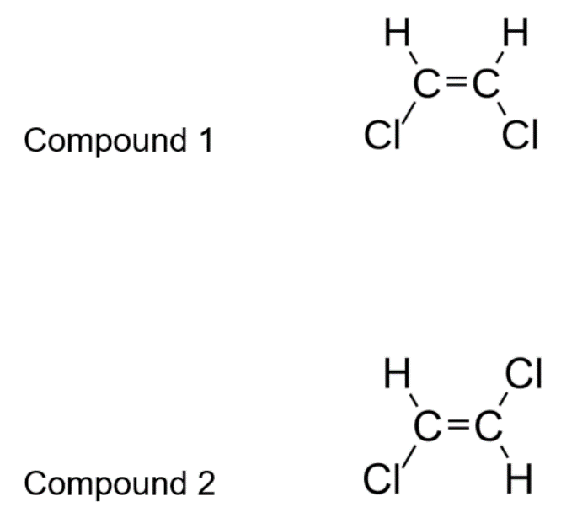

1. (1) is *cis*-1,2-dichloroethene and (2) is *trans*-1,2-dichloroethene.
2. Compounds (1) and (2) are geometric isomers.
3. (1) is *trans*-1,2-dichloroethene and (2) is *cis*-1,2-dichloroethene.
4. These compounds will have different melting and boiling points.
5. Which compound, when reacted with chlorine, Cl2, in the presence of UV light, would produce chlorocyclohexane?
6. benzene
7. cyclohexane
8. cyclohexene
9. hexane

**Section 2: Short Answer**

*Write your answer in the spaces provided*

1. Draw the structural formula for (3 marks)

|  |  |
| --- | --- |
| 1. tetrafluoromethane |  |
| 1. 1,5-dichloropent-2-ene |  |
| 1. 1-propylbenzene |  |

1. Name the following compounds using the IUPAC system (3 marks)
2. CH2 = CH - CH2 – CH3

CH3

|

1. CH3 - CH2 – CH - CH - CH3

|

CH3

1. H

|

CH3 – C = C – CH3

|

H

1. Write balanced equations for the following reactions and **indicate the type of reaction**.

(4 marks)

1. Pent-2-ene is mixed with chlorine gas in the presence of UV light
2. Hexane is combusted in excess oxygen

**END OF TEST**